**Institute of Engineering & Technology**

**Devi Ahilya Vishwavidyalaya, Indore**

**Department of Computer Science & Engineering**



**Object Oriented Programming (CER3C2)**

**Assignment-4**

**(Constructors & Objects)**

**Submitted To: Submitted By:**

**Harshita Sharma Mam Tanishq Chauhan (21C3184)**

**CS-Dept CS “B” 2nd Year**

**IET-DAVV**

**Assignment-4**

1. Write the distance converter program that converts entered number into meter, kilometer, hectameter and decameter by using objects, methods and constructor.

import java.util.*;

public class DistanceConverter {

    Scanner s= new Scanner(System.in);

    Double km,m,hm,dm;

    int convert(Double value)

    {

        System.out.println("enter value in kilometre");

        System.out.println("enter value in metre");

        System.out.println("enter value in hectometre");

        System.out.println("enter value in decametre");

        return 0;

    }

    int kmToAll(Double km)

    {

        System.out.println("VAlue in Meter ="+km*1000);

        System.out.println("VAlue in HectoMeter ="+km*10);

        System.out.println("VAlue in DecaMeter ="+km*100);

        return 0;

    }

    int mToAll(Double m)

    {

        System.out.println("VAlue in kiloMeter ="+m/1000);

        System.out.println("VAlue in HectoMeter ="+m/100);

        System.out.println("VAlue in DecaMeter ="+m/10);

        return 0;

    }

    int hmToAll(Double hm)

    {

        System.out.println("VAlue in kiloMeter ="+hm/10);

        System.out.println("VAlue in Meter ="+hm*100);

        System.out.println("VAlue in DecaMeter ="+hm*10);

        return 0;

    }

    int dmToAll(Double dm)

    {

        System.out.println("VAlue in kiloMeter ="+dm/100);

        System.out.println("VAlue in Meter ="+dm*10);

        System.out.println("VAlue in hectoMeter ="+dm/10);

        return 0;

    }

    public static void main(String[] args)

    {

        DistanceConverter d= new DistanceConverter();

        int choice ;

        Scanner s = new Scanner(System.in);

        System.out.println("Enter your choice");

        System.out.println("Press 1 to convert from Kilometer to All");

        System.out.println("Press 2 to convert from Meter to All");

        System.out.println("Press 3 to convert from Hectameter to All");

        System.out.println("Press 4 to convert from Decameter to All");

        choice = s.nextInt();

        switch (choice)

        {

            case 1:

            System.out.println("Enter Kilometer Value");

            Double km = s.nextDouble();

            d.kmToAll(km);

            break;

            case 2:

            System.out.println("Enter Meter Value:");

            Double m = s.nextDouble();

            d.mToAll(m);

            break;

            case 3:

            System.out.println("Enter Hectameter Value:");

            Double hm = s.nextDouble();

            d.hmToAll(hm);

            break;

            case 4:

            System.out.println("Enter Decameter Value:");

            double dm = s.nextDouble();

            d.dmToAll(dm);

            break;

            default:

            break;

        }

    }

}

**Output**

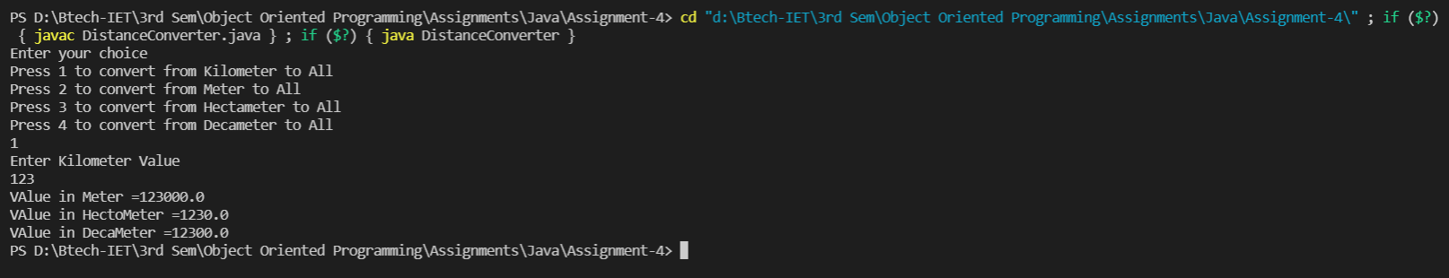

1. Define a class which represent the bank account of a person. Include data members like name of depositor, account number, type of account, balance amount in the account and perform following task:

* Assign Initial values to data members
* Deposit an amount
* Withdraw an amount after checking the balance
* To display name and balance

import java.util.*;

public class BankingDetails

{

    private String accno;

    private String name;

    private String acc_type;

    private long balance;

    Scanner sc = new Scanner(System.in);

    public void openAccount()

    {

        System.out.print("Enter Account No: ");

        accno = sc.next();

        System.out.print("Enter Account type: ");

        acc_type = sc.next();

        System.out.print("Enter Name: ");

        name = sc.next();

        System.out.print("Enter Balance: ");

        balance = sc.nextLong();

    }

    public void showAccount()

    {

        System.out.println("Name of account holder: " + name);

        System.out.println("Account no.: " + accno);

        System.out.println("Account type: " + acc_type);

        System.out.println("Balance: " + balance);

    }

    public void deposit()

    {

        long amt;

        System.out.println("Enter the amount you want to deposit: ");

        amt = sc.nextLong();

        balance = balance + amt;

    }

    public void withdrawal()

    {

        long amt;

        System.out.println("Enter the amount you want to withdraw: ");

        amt = sc.nextLong();

        if (balance >= amt) {

            balance = balance - amt;

            System.out.println("Balance after withdrawal: " + balance);

        } else {

            System.out.println("Your balance is less than " + amt + "\tTransaction failed...!!" );

        }

    }

    public boolean search(String ac_no)

    {

        if (accno.equals(ac_no)) {

            showAccount();

            return (true);

        }

        return (false);

    }

}

class bankservices

{

    public static void main(String args[])

    {

        Scanner sc = new Scanner(System.in);

        System.out.print("How many number of customers do you want to input? ");

        int n = sc.nextInt();

        BankingDetails C[] = new BankingDetails[n];

        for (int i = 0; i < C.length; i++)

        {

            C[i] = new BankingDetails();

            C[i].openAccount();

        }

        int ch;

        do {

            System.out.println("\n BANK SERVICES");

            System.out.println("1. Display all account details \n 2. Search by Account number\n 3. Deposit the amount \n 4. Withdraw the amount \n 5.Exit ");

            System.out.println("Enter your choice: ");

            ch = sc.nextInt();

            switch (ch)

                {

                    case 1:

                    for (int i = 0; i < C.length; i++)

                    {

                        C[i].showAccount();

                    }

                    break;

                    case 2:

                    System.out.print("Enter account no. you want to search: ");

                    String ac_no = sc.next();

                    boolean found = false;

                    for (int i = 0; i < C.length; i++)

                    {

                        found = C[i].search(ac_no);

                        if (found)

                        {

                            break;

                        }

                    }

                    if (!found)

                    {

                        System.out.println("Search failed! Account doesn't exist..!!");

                    }

                    break;

                    case 3:

                    System.out.print("Enter Account no. : ");

                    ac_no = sc.next();

                    found = false;

                    for (int i = 0; i < C.length; i++)

                    {

                        found = C[i].search(ac_no);

                        if (found)

                        {

                            C[i].deposit();

                            break;

                        }

                    }

                    if (!found)

                    {

                        System.out.println("Search failed! Account doesn't exist..!!");

                    }

                    break;

                    case 4:

                    System.out.print("Enter Account No : ");

                    ac_no = sc.next();

                    found = false;

                    for (int i = 0; i < C.length; i++)

                    {

                        found = C[i].search(ac_no);

                        if (found)

                        {

                            C[i].withdrawal();

                            break;

                        }

                    }

                    if (!found)

                    {

                        System.out.println("Search failed! Account doesn't exist..!!");

                    }

                    break;

                    case 5:

                    System.out.println("See you soon...");

                    break;

                }

        }

        while (ch != 5);

    }

}

**Output**



1. A bookshop maintains the inventory of books that are being sold at the shop. The list includes details such as author, title, price, publisher and stock position. Whenever the customer wants a book, the sales person inputs the title and author, and the system searches the list and displays whether it is available or not. If it is not, an appropriate message is displayed. If it is, then the system displays the book details and request for the number of copies required. If requested copies are available, the total cost of requested copies is displayed, otherwise the message “Required copies not in stock” is displayed.

import java.util.*;

public class Inventory {

    float price ;

    int stock ;

    String authorname ,title,publisher ;

    Inventory(String t,String an,int st,String pub,float p)

    {

        price= p;

        stock=st ;

        authorname=an ;

        title=t ;

        publisher=pub;

    }

    public static void main(String[] args)

    {

        Scanner sc = new Scanner(System.in);

        Inventory c1=new Inventory("Computer Fundamentals","Gupta",200,"Prakashan",300);

        Inventory c2=new Inventory("Data Structures and Algorithms using C++","E.Balagurusami",150,"MChill",200);

        Inventory c3=new Inventory("The Object Oriented Thought Process","Matt",200,"Weisfeld",320);

        Inventory c4=new Inventory("The Development of Arab Mathematics: b/w Arithematic and Algebra","Roshdi",120,"Rashed",230);

        System.out.println("Enter Title:");

        String ti=sc.nextLine();

        System.out.println("Enter Author:");

        String Au=sc.nextLine();

        if((c1.title).equalsIgnoreCase(ti) && (c1.authorname).equalsIgnoreCase(Au) )

        {

            System.out.println("------Book Details-----") ;

            System.out.println("Title: "+c1.title) ;

            System.out.println("Author: "+c1.authorname) ;

            System.out.println("Publisher: "+c1.publisher) ;

            System.out.println("Price: "+c1.price) ;

            System.out.println("Stock: "+c1.stock) ;

            System.out.println("Enter req copies: ") ;

            float r=sc.nextFloat() ;

            if(c1.stock -(int)r>=0)

            {

                r=r*c1.price;

                System.out.println("Total price: "+r) ;

            }

            else

            System.out.println("Required copies currently unavailable") ;

        }

        else if((c2.title).equalsIgnoreCase(ti) && (c2.authorname).equalsIgnoreCase(Au) )

        {

            System.out.println("------Book Details-----") ;

            System.out.println("Title: "+c2.title) ;

            System.out.println("Author: "+c2.authorname) ;

            System.out.println("Publisher: "+c2.publisher) ;

            System.out.println("Price: "+c2.price) ;

            System.out.println("Stock: "+c2.stock) ;

            System.out.println("Enter req copies: ") ;

            float r=sc.nextFloat() ;

            if(c2.stock -(int)r>=0)

            {

                r=r*c2.price;

                System.out.println("Total price: "+r) ;

            }

            else

            System.out.println("Required copies not in stock") ;

        }

        else if((c3.title).equalsIgnoreCase(ti) && (c3.authorname).equalsIgnoreCase(Au) )

        {

            System.out.println("------Book Details-----") ;

            System.out.println("Title: "+c3.title) ;

            System.out.println("Author: "+c3.authorname) ;

            System.out.println("Publisher: "+c3.publisher) ;

            System.out.println("Price: "+c3.price) ;

            System.out.println("Stock: "+c3.stock) ;

            System.out.println("Enter req copies: ") ;

            float r=sc.nextFloat() ;

            if(c3.stock -(int)r>=0)

            {

                r=r*c3.price;

                System.out.println("Total price: "+r) ;

            }

            else

            System.out.println("Required copies not in stock") ;

        }

        else if((c4.title).equalsIgnoreCase(ti) && (c4.authorname).equalsIgnoreCase(Au) )

        {

            System.out.println("------Book Details-----") ;

            System.out.println("Title: "+c4.title) ;

            System.out.println("Author: "+c4.authorname) ;

            System.out.println("Publisher: "+c4.publisher) ;

            System.out.println("Price: "+c4.price) ;

            System.out.println("Stock: "+c4.stock) ;

            System.out.println("Enter req copies: ") ;

            float r=sc.nextFloat() ;

            if(c4.stock -(int)r>=0)

            {

                r=r*c4.price;

                System.out.println("Total price: "+r) ;

            }

            else

            System.out.println("Required copies not in stock") ;

        }

        else

        System.out.println("Book Not found ") ;

    }

}

**Output**

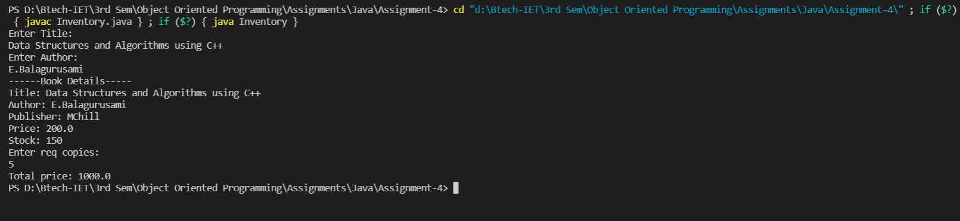

1. Define a class which represents management of books in Library. Include data members like unique id, title, author of each book and unique_id to a member. Include member function which provide facilities to Issue or reissue books, Return Books and track the record of the book, fine calculation.

import java.util.Arrays;

import java.util.Scanner;

public class Library {

    String authorname ,title,publisher ;

    String issue;

    Library(String t,String an,String pub,String id)

    {

        authorname=an ;

        title=t ;

        publisher=pub ;

        issue=id ;

    }

    Library(String t,String an,String pub)

    {

        authorname=an ;

        title=t ;

        publisher=pub ;

        issue="Null" ;

    }

    void issuebook()

    {

    }

    public static void main(String[] args)

    {

        Library [] c ;

        c = new Library[17];

        Scanner sc = new Scanner(System.in);

        c[1]=new Library("Fundamentals of C","Deepak","Balaji") ;

        c[2]=new Library("Fundamentals of C++","Dheeraj","Balaji") ;

        c[3]=new Library("Concepts of Java","Lalu","Balaji","20C3181") ;

        c[4]=new Library("Easy Cp","Bhiya","Balaji","20C3182") ;

        c[5]=new Library("Concepts of C","Janvi","Retry","20C2183") ;

        c[6]=new Library("Getting Ready for CS","Shastri","Cengage") ;

        c[7]=new Library("HTMl The Basics","Abhishek","Cengage") ;

        c[8]=new Library("OOPS Made Easy","Vivek","Balaji") ;

        c[9]=new Library("Fundamentals of Node","Deepak","Balaji") ;

        c[10]=new Library("Starting with CP","Dheeraj & Bhiyu","Arihant") ;

        c[11]=new Library("DS in Java","Lata Parikh","Balaji") ;

        c[12]=new Library("Algorithms CLRS","CLRS","Pearson") ;

        c[13]=new Library("SQL Database","Joseph","ReLearn","203001") ;

        c[14]=new Library("Concepts of CSS","Deepak","Cengage") ;

        c[15]=new Library("Wed Dev Basics","Ahirvar","Balaji","20C3184") ;

        c[16]=new Library("OOPS Advanced","Vivek","Pearson") ;

        System.out.println("Enter your ID:") ;

        String id=sc.nextLine() ;

        System.out.println("Enter Title of Book You Want to Issue:") ;

        String T=sc.nextLine() ;

        for(int i=1;i<17;i++)

        {

            if((c[i].issue).equalsIgnoreCase(id))

            {

                System.out.println("A Book is Already issued by Your Id:"+c[i].title) ;

                break ;

            }

            else if((c[i].title).equalsIgnoreCase(T) && c[i].issue=="Null")

            {

                c[i].issue=id ;

                System.out.println("Book Issued by:"+id);

            }

        }

        System.out.println("Want to Return a Book? ") ;

        Scanner s=new Scanner(System.in);

        String t=s.nextLine() ;

        if(t.equalsIgnoreCase("y"))

        {

            System.out.println("Enter Title of Book You Want to Return:") ;

        }

        String R=s.nextLine() ;

        System.out.println("Enter No. of Days late:") ;

        int n=s.nextInt();

        System.out.println("Fine: "+n*5) ;

        for(int i=1;i<17;i++)

        {

            if((c[i].title).equalsIgnoreCase(R))

            {

                c[i].issue="Null" ;

            }

        }

        System.out.println("The Book Record is:");

        for(int i=1; i<17; i++)

        {

            System.out.println("Title:" + c[i].title);

            System.out.println("Author:" + c[i].authorname);

            System.out.println("Publisher:" + c[i].publisher);

            System.out.println("Issued By:" + c[i].issue);

            System.out.println();

        }

    }

}

**Output**

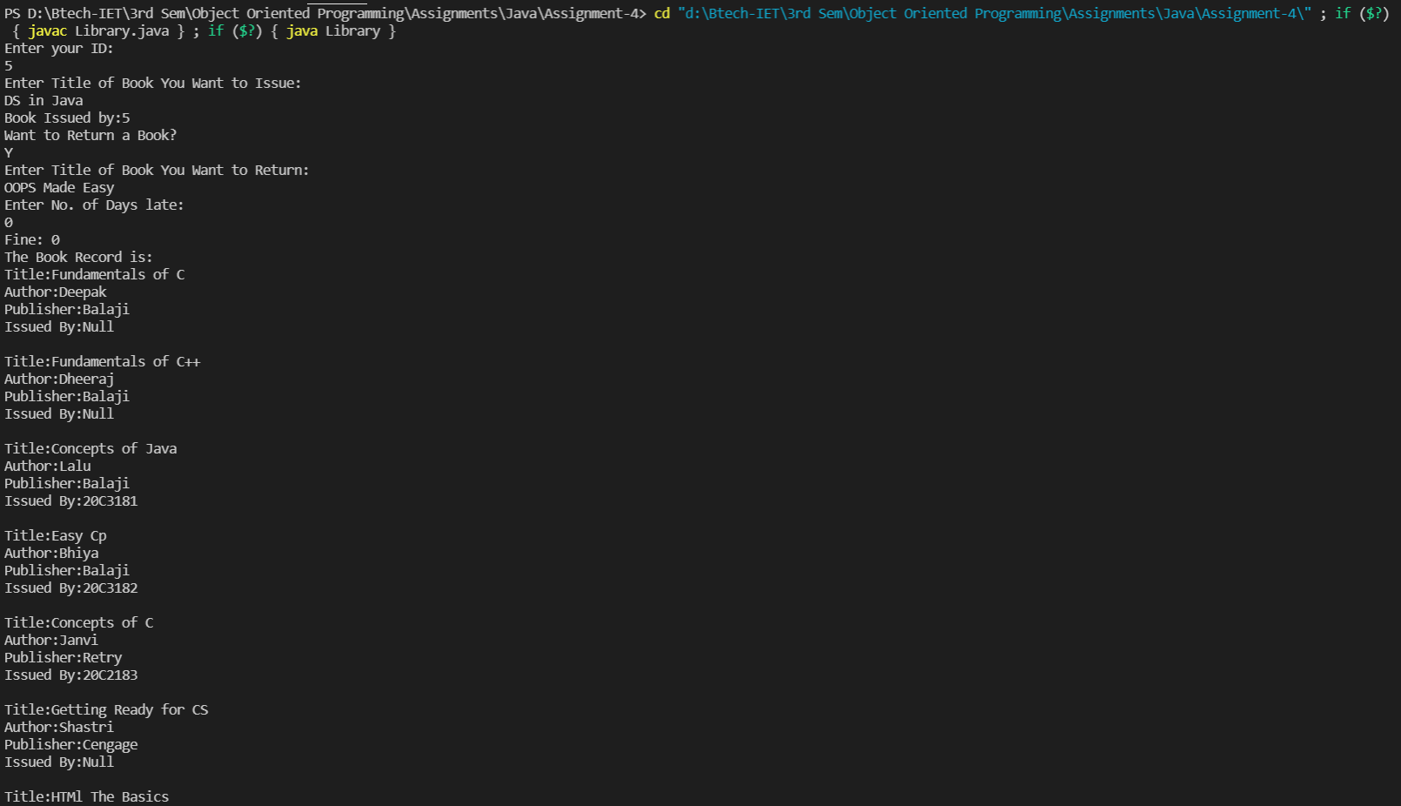



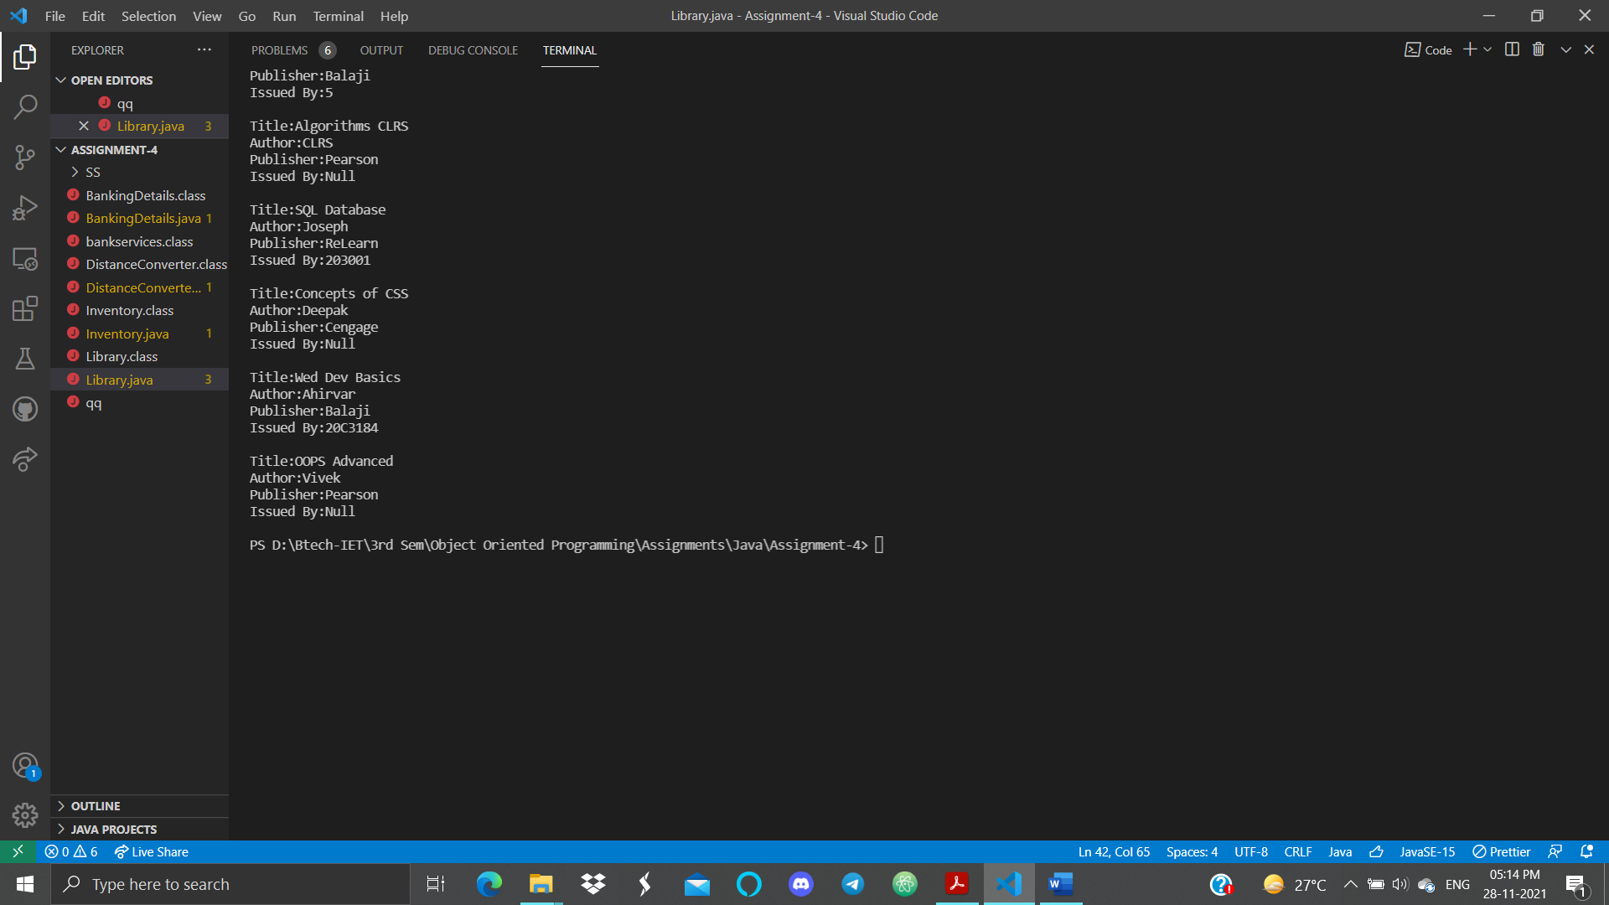

1. Write a program to find area and perimeter of Square, Rectangle, Circle, Cone, Parallelogram. Use the concept of method overloading.

import java.util.Arrays;

import java.util.Scanner;

public class MethodoverLoading {

    void areaandperi(float a)

        {

            System.out.println("Area of Square is : "+ Math.pow(a,2));

            System.out.println("Perimeter of Square is : "+ 4*a);

            System.out.println();

        }

        void areaandperi(float a,float b)

        {

            System.out.println("Area of Rectangle is : "+a*b);

            System.out.println("Perimeter of Rectangle is : "+ 2*(a+b));

            System.out.println();

        }

        void areaandperi(double a)

        {

            System.out.println("Area of Circle is : "+ 3.14*(Math.pow(a,2)));

            System.out.println("Perimeter of Circle is : "+ 3.14*2*a);

            System.out.println();

        }

        void areaandperi(double a,double b)

        {

            System.out.println("Area of Cone is : "+ 3.14*a*(a+b));

            System.out.println("Perimeter of Cone is : "+ 3.14*2*a);

            System.out.println();

        }

        void areaandperi(float a,float b,double h)

        {

            System.out.println("Area of parallelogram is : "+ b*h);

            System.out.println("Perimeter of Parallelogram is : "+ 2*(a+b));

            System.out.println();

        }

        public static void main(String[] args)

        {

            MethodoverLoading a=new MethodoverLoading() ;

            a.areaandperi(4) ;

            a.areaandperi(11,4) ;

            a.areaandperi(4.0) ;

            a.areaandperi(4.0,5.0) ;

            a.areaandperi(5,2,6.0) ;

        }

}

**Output**

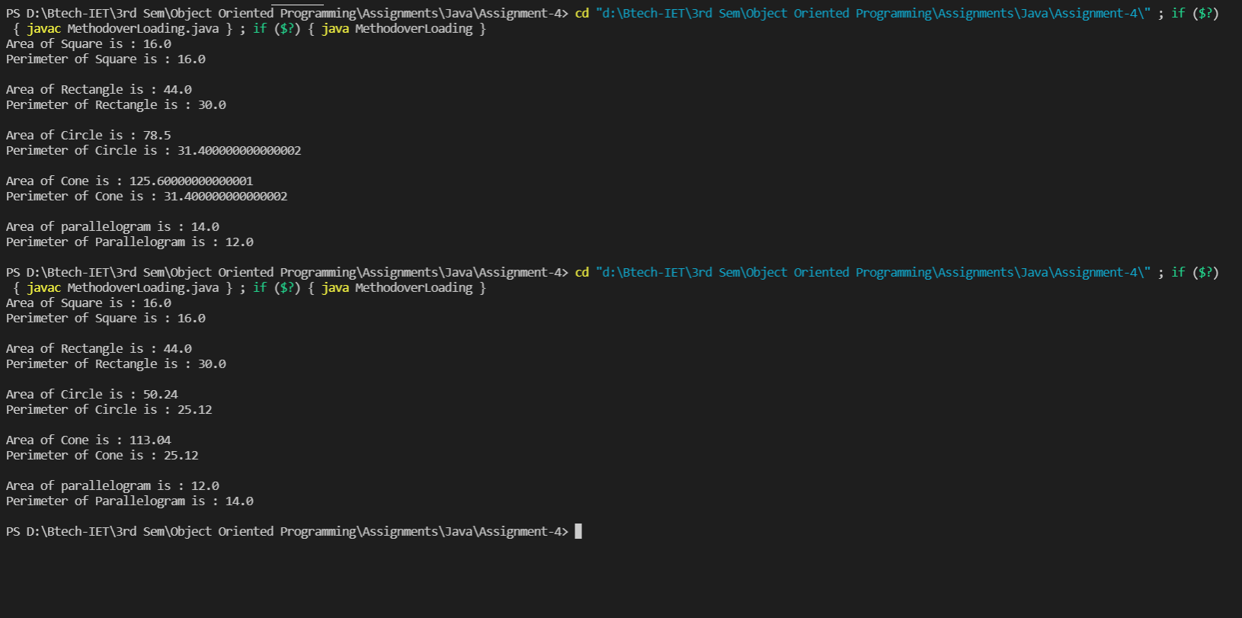

1. Define a class for rectangle objects defined by two points, the top left and bottom right corners of the rectangle. Include a constructor to copy a rectangle, a method to return a rectangle object that encloses the current object and the rectangle passed as an argument and method to display the defining points of a rectangle. Test the class by creating for rectangles and combining these cumulatively to end up with a rectangle enclosing them all. Output the defining points of all these rectangle you create.

import java.util.Arrays;

import java.util.Scanner;

class coordinates

{

    public int x;

    public int y;

};

public class Rectangle {

    Scanner sc= new Scanner(System.in);

    coordinates bl=new coordinates();

    coordinates br=new coordinates();

    coordinates tl=new coordinates();

    coordinates tr=new coordinates();

    void cords()

    {

        System.out.println("Enter the Coords of Bottom Left Corner : ");

        System.out.print("x: ");

        bl.x=sc.nextInt();

        System.out.print("y: ");

        bl.y=sc.nextInt();

        System.out.println("Enter the Coords of Top Right Corner : ");

        System.out.print("x: ");

        tr.x=sc.nextInt();

        System.out.print("y: ");

        tr.y=sc.nextInt();

    }

    Rectangle()

    {

        cords();

        tl.x=bl.x;

        tl.y=tr.y;

        br.x=tr.x;

        br.y=bl.y;

    }

    Rectangle(int a)

    {

    }

    void Displayc()

    {

        System.out.print("Bottom left : ("+bl.x+","+bl.y+")"+"Top right : ("+tr.x+","+tr.y+")") ;

    }

    Rectangle(Rectangle a,Rectangle b,Rectangle c,Rectangle d)

    {

        int p=0 ;

        Rectangle e=new Rectangle(p) ;

        e.bl.x=Math.min(a.bl.x,b.bl.x) ;

        e.bl.x=Math.min(e.bl.x,c.bl.x) ;

        e.bl.x=Math.min(e.bl.x,d.bl.x) ;

        e.tl.x=e.bl.x ;

        e.bl.y=Math.min(a.bl.y,b.bl.y) ;

        e.bl.y=Math.min(e.bl.y,c.bl.y) ;

        e.bl.y=Math.min(e.bl.y,d.bl.y) ;

        e.br.y=e.bl.y ;

        e.tr.x=Math.max(a.tr.x,b.tr.x) ;

        e.tr.x=Math.max(e.tr.x,c.tr.x) ;

        e.tr.x=Math.max(e.tr.x,d.tr.x) ;

        e.br.x=e.tr.x ;

        e.tr.y=Math.max(a.tr.y,b.tr.y) ;

        e.tr.y=Math.max(e.tr.y,c.tr.y) ;

        e.tr.y=Math.max(e.tr.y,d.tr.y) ;

        e.tl.y=e.tr.y;

        e.Displayc();

    }

    public static void main(String[] args)

    {

        Rectangle a=new Rectangle() ;

        Rectangle b=new Rectangle() ;

        Rectangle c=new Rectangle() ;

        Rectangle d=new Rectangle() ;

        System.out.println("The Defining points of Enclosing Rectangle are :");

        Rectangle e=new Rectangle(a,b,c,d) ;

    }

}

**Output**

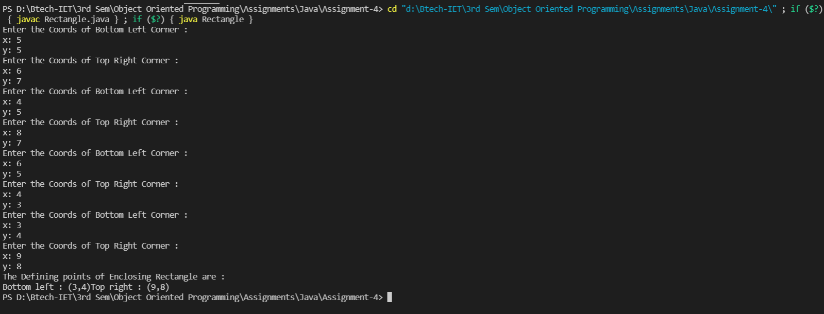

1. Define a class, mcmlength, to represent a length measured in meters, centimeters, and millimeters, each stored as integer. Include methods to add and subtract objects, to multiply and divide object by an integer value, to calculate and area resulting from the product of the two objects, and to compare objects. Include constructors that accept three arguments, which creates an object with length set to zero. Check the class by creating some objects and testing the class operation.

import java.util.Arrays;

import java.util.Scanner;

import javax.lang.model.util.ElementScanner14;

public class mcmlength {

    int m,cm,mm,r;

    mcmlength(int a,int b,int c)

    {

        m = a;

        cm = b;

        mm = c;

        r = (m*1000 ) + (cm*10) + mm;

    }

    mcmlength(int h)

    {

        int m,cm,mm,r;

    }

    void backto(int n)

    {

        int M = n/1000;

        n = n%1000;

        int Ce = n/10;

        n = n%10;

        m= M;

        cm = Ce;

        mm = n;

    }

    void Display(mcmlength a)

    {

        System.out.println(a.m+" meter "+a.cm+" centimeter "+a.mm+" milimeter ");

    }

    void subs(mcmlength a1,mcmlength a2)

    {

        int p = 0;

        mcmlength y=new mcmlength(p);

        y.r = a1.r - a2.r;

        y.backto(y.r);

        Display(y);

    }

    void add(mcmlength a1,mcmlength a2)

    {

        int p = 0;

        mcmlength y = new mcmlength(p);

        y.r = a1.r + a2.r;

        y.backto(y.r);

        Display(y);

    }

    void Mul(mcmlength a1,int n)

    {

        mcmlength y = new mcmlength(n*a1.m,n*a1.cm,n*a1.mm);

        y.backto(y.r);

        Display(y);

    }

    void Div(mcmlength a1,int n)

    {

        int p = 0;

        mcmlength y = new mcmlength(p);

        y.r = (a1.r /n);

        y.backto(y.r);

        Display(y);

    }

    void area(mcmlength a1,mcmlength a2)

    {

        int p=0;

        mcmlength y = new mcmlength(p);

        y.r = (a1.r)*(a2.r);

        System.out.println("Area is: "+y.r+" sq mm");

    }

    void compare(mcmlength a1,mcmlength a2)

    {

        if(a1.r>a2.r)

        {

            System.out.print("Object "+a1.m+"m "+a1.cm+"cm "+a1.mm+"mm is bigger than "+a2.m+"m "+a2.cm+"cm "+a2.mm+"mm ") ;

        }

        else

        {

            System.out.print("Object "+a2.m+"m "+a2.cm+"cm "+a2.mm+"mm is bigger than "+a1.m+"m "+a1.cm+"cm "+a1.mm+"mm ");

        }

    }

    public static void main(String[] args)

    {

        Scanner sc= new Scanner(System.in);

        int m1,m2,cm1,cm2,mm1,mm2;

        System.out.println("Enter value for object 1 in Meter ,Centimeter,Millimeter ");

        m1=sc.nextInt();

        cm1=sc.nextInt();

        mm1=sc.nextInt();

        System.out.println("Enter value for object 2 in Meter ,Centimeter,Millimeter ");

        m2=sc.nextInt();

        cm2=sc.nextInt();

        mm2=sc.nextInt();

        mcmlength a1=new mcmlength(m1,cm1,mm1);

        mcmlength a2=new mcmlength(m2,cm2,mm2);

        System.out.print("Ans of addition is : ");

        a1.add(a1,a2);

        System.out.print("Ans of substraction is : ");

        a1.subs(a1,a2);

        System.out.print("Enter no. thorugh which Multiplication is to ber performed with object1 ");

        m1=sc.nextInt();

        System.out.print("Ans of Mulitiplication is : ");

        a1.Mul(a1, m1);

        System.out.print("Enter no. thorugh which Division is to ber performed with object1 ");

        m1=sc.nextInt();

        System.out.print("Ans of Division is : ");

        a1.Div(a1, m1);

        System.out.print("Ans of area enclosed by object 1 and object 2 is : ");

        a1.area(a1, a2);

        System.out.print("Ans of Comparison is : ");

        a1.compare(a1, a2);

    }

}

**Output**

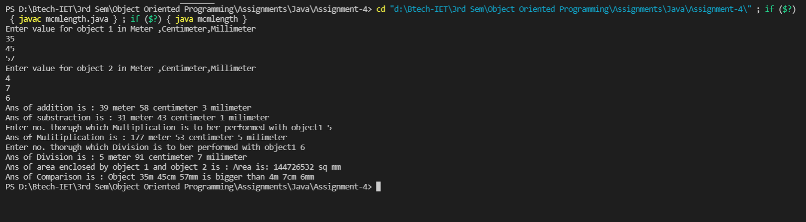

1. Define a class, tkgweight to represent a weight in tons, kilograms, and grams and include a similar range of methods and constructors as the previous question. Demonstrate this class by creating and operating some objects of the class.

import java.util.Arrays;

import java.util.Scanner;

public class tkgweight {

    int t,kg,g;

    int r;

    tkgweight(int a,int b,int c)

    {

        t=a;

        kg=b;

        g=c;

        r=(t * 1000000) + (kg * 1000) + g;

    }

    tkgweight(int h)

    {

        int t,kg,g;

        int r;

    }

    void backto(int n)

    {

        int M = n/1000000;

        n = n%1000000;

        int Ce = n/1000;

        n = n%1000;

        t = M;

        kg = Ce;

        g = n;

    }

    void Display(tkgweight a)

    {

        System.out.println(a.t+" Tons "+a.kg+" Kilograms "+a.g+" Grams ");

    }

    void subs(tkgweight a1,tkgweight a2)

    {

        int p= 0;

        tkgweight y = new tkgweight(p);

        y.r = a1.r - a2.r;

        y.backto(y.r);

        Display(y);

    }

    void add(tkgweight a1,tkgweight a2)

    {

        int p= 0;

        tkgweight y=new tkgweight(p);

        y.r = a1.r + a2.r;

        y.backto(y.r);

        Display(y);

    }

    void Mul(tkgweight a1,int n)

    {

        tkgweight y=new tkgweight(n*a1.t,n*a1.kg,n*a1.g);

        y.backto(y.r);

        Display(y);

    }

    void Div(tkgweight a1,int n)

    {

        int p=0;

        tkgweight y=new tkgweight(p);

        y.r=(a1.r /n);

        y.backto(y.r);

        Display(y);

    }

    void compare(tkgweight a1,tkgweight a2)

    {

        if(a1.r>a2.r)

        {

            System.out.print("Object "+a1.t+"ton "+a1.kg+"kg "+a1.g+"g is bigger than "+a2.t+"ton "+a2.kg+"kg "+a2.g+"g ");

        }

        else

        {

            System.out.print("Object "+a2.t+"ton "+a2.kg+"kg "+a2.g+"g is bigger than "+a1.t+"ton "+a1.kg+"kg "+a1.g+"g ");

        }

    }

    public static void main(String[] args)

    {

        Scanner sc= new Scanner(System.in);

        int m1,m2,cm1,cm2,mm1,mm2;

        System.out.println("Enter Value for Object 1 in Ton,Kilogram,Gram:");

        m1=sc.nextInt();

        cm1=sc.nextInt();

        mm1=sc.nextInt();

        System.out.println("Enter Value for Object 2 in Ton,Kilogram,Gram:");

        m2=sc.nextInt();

        cm2=sc.nextInt();

        mm2=sc.nextInt();

        tkgweight a1=new tkgweight(m1,cm1,mm1);

        tkgweight a2=new tkgweight(m2,cm2,mm2);

        System.out.print("Ans of Addition is:") ;

        a1.add(a1,a2);

        System.out.print("Ans of Substraction is:");

        a1.subs(a1,a2);

        System.out.print("Enter no. Thorugh which Multiplication is to be Performed with Object1:");

        m1=sc.nextInt();

        System.out.print("Ans of Multiplication is:");

        a1.Mul(a1, m1);

        System.out.print("Enter no. thorugh which Division is to be Performed with Object1:");

        m1=sc.nextInt();

        System.out.print("Ans of Division is:");

        a1.Div(a1, m1);

        System.out.print("Ans of Comparison is:");

        a1.compare(a1, a2);

    }

}

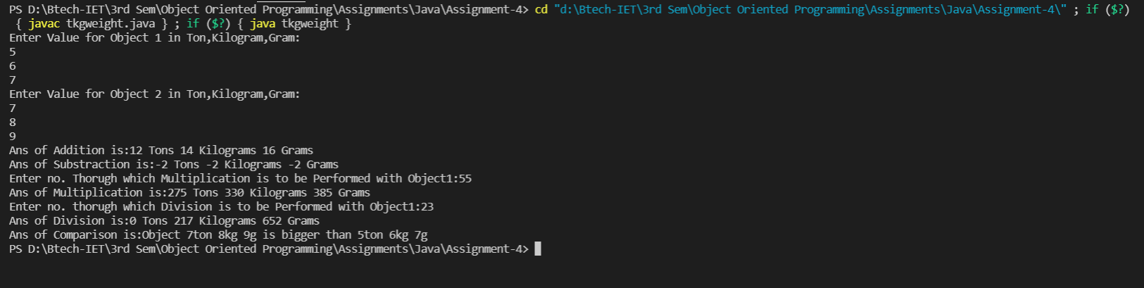**Output**